**PAKISTAN LEGAL ANALYSIS OF MONSOON FLOODS TRIGGERED BY CLIMATE CHANGE IN PAKISTAN:**

**Causes, Consequences, and Remedial Strategies**

**A Research Paper**  
**Author:** Munir Ahmad Dar, Advocate  
**Publisher & Editor-in-Chief:** Lyallpur Post, Pakistan–Canada  
**Email:** [munirdar41@gmail.com](mailto:munirdar41@gmail.com)

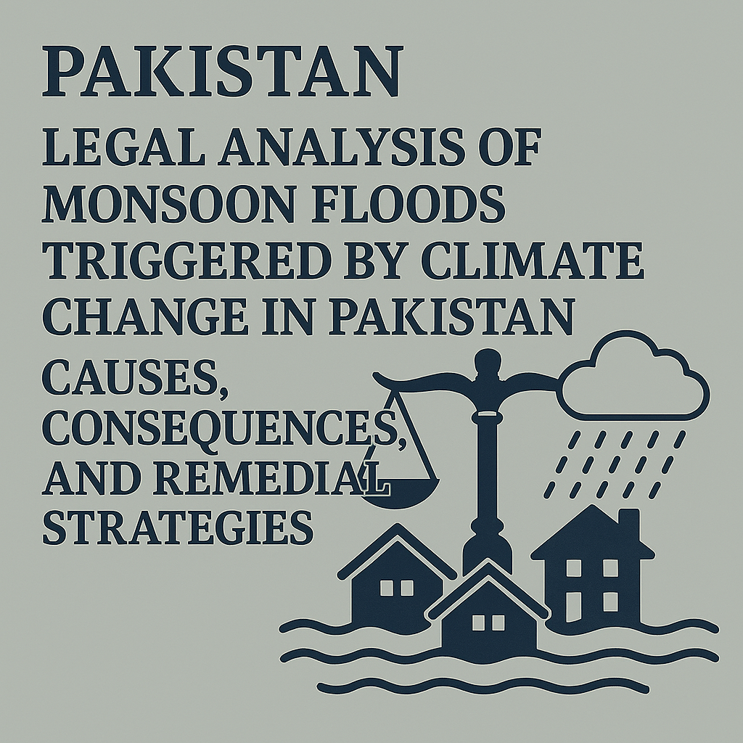

**ABSTRACT**: Pakistan’s vulnerability to monsoon floods has intensified due to climate change, poor governance, and infrastructural neglect. This paper presents a legal analysis of climate-induced floods, examining their causes, consequences, and the failures of domestic and international legal systems. Based on year-by-year flood data, the research highlights the urgent need for climate adaptation legislation, international legal advocacy, and integrated water resource management. The paper concludes with policy recommendations to transform Pakistan’s reactive disaster strategy into a proactive, legally grounded framework.

**KEYWORDS:** Climate justice; Monsoon floods; Pakistan; Environmental law; Displacement; Legal reform; Sovereignty risk; Climate adaptation.

**INTRODUCTION**

The monsoon season from July to September 2025 has taken a devastating turn in Pakistan. The 2022 floods alone displaced over 33 million people and caused more than USD 16 billion in damages. These events are not merely natural disasters; they reflect legal and institutional failures. This paper reviews the legal dimensions of monsoon floods in Pakistan, using annual data to propose a framework for legal reform and climate adaptation. The following are the Year-by-Year Impact of Monsoon Floods in Pakistan

**2010 - A Turning Point**

The 2010 monsoon floods were among the worst natural disasters in Pakistan’s history, causing over 2,000 deaths and affecting nearly 20 million people, with damages reaching USD 10 billion. The catastrophe exposed the absence of national climate legislation and weak zoning laws in flood-prone areas. Despite this, the legal response remained fragmented, and no comprehensive legislation was enacted.

**2011 – Repetition Without Reform**

Floods in 2011 claimed 361 lives and affected 5.3 million people, with estimated damages of USD 2 billion. The lack of integrated disaster management and legal provisions for emergency shelter and relocation revealed a failure to learn from the previous year. The absence of enforceable tenancy protections and property restoration mechanisms left victims legally vulnerable.

**2012 – Persistent Fragility**

Though less severe, the 2012 floods still resulted in over 100 deaths and economic losses exceeding USD 1.5 billion. Their recurrence underscored the urgent need for robust land-use regulations and early warning systems. Yet, legal inertia persisted, with no significant amendments to environmental or urban planning laws.

**2022 – Emergence of a Climate Crisis**

The 2022 monsoon season marked a watershed moment in Pakistan’s climate history. With 1,739 deaths and over 33 million affected, damages reached USD 16.3 billion. Scientific studies linked rainfall intensity to human activity, offering Pakistan a potential legal basis for international claims. Domestically, the absence of climate adaptation laws, outdated infrastructure, and poor urban drainage worsened the disaster. The legal system failed to deliver timely justice or enforce accountability.

**2025 – Ongoing Crisis**

By August 2025, Pakistan faced another wave of severe monsoon flooding, with at least 785 deaths and over 50,000 displaced. While financial assessments are ongoing, initial reports indicate extensive damage to housing, agriculture, and public infrastructure. The continued absence of mandatory forecasting systems and accountability mechanisms reflects a troubling trend. Despite repeated calls for reform, Pakistan still lacks a comprehensive climate adaptation law, leaving millions at risk.

**LEGAL DIMENSIONS AND PROXIMATE CAUSES**

**International Climate Obligations**

Pakistan contributes less than 1% to global greenhouse gas emissions but remains among the most climate-vulnerable nations. Under the Paris Agreement, developed countries are obligated to support vulnerable nations through climate finance and loss-and-damage mechanisms. The 2022 floods, linked to human activity, provide Pakistan with legal grounds for international compensation claims.

**Domestic Regulatory Failures**

Pakistan’s legal framework has failed to mitigate flood risks due to:

* **Poor Land-Use Planning:** Construction in flood zones violates zoning laws under the Punjab Local Government Act (2019) and the Sindh Building Control Ordinance (1979).
* **Infrastructure Neglect:** Outdated flood control systems and inadequate urban drainage breach state responsibilities.
* **Environmental Degradation:** Deforestation and soil erosion contravene the Pakistan Environmental Protection Act (1997).

**LEGAL AND SOCIOECONOMIC IMPACTS**

**Forced Displacement and Property Rights**

The International Covenant on Economic, Social and Cultural Rights (ICESCR), adopted by the UN General Assembly on 16 December 1966 and effective from 3 January 1976, aims to uphold human dignity, equal rights, and global justice. Flood-induced displacement violates these principles.

**Public Health Crisis**

Flood-related health emergencies infringe on the right to health under Article 12 of the ICESCR. Lack of clean water and medical services breaches state obligations.

**Economic Liability and Sovereignty Risk**

Flood damages exceeding USD 16 billion in 2022 severely impacted Pakistan’s financial capacity and credit rating. Legal mechanisms such as sovereign climate bonds and disaster liability frameworks are essential to address this risk.

**PROPOSED LEGAL AND POLICY SOLUTIONS**

**Climate Adaptation Legislation**

Parliament should enact a “Climate Adaptation Act” that includes:

* Flood risk assessments for infrastructure
* Enforcement of construction codes in flood zones
* Legal protection for ecosystems

**Early Warning and Communication Systems**

A legally mandated early warning system should include:

* Satellite forecasting
* Mobile alerts
* Community-based preparedness

**Integrated Water Resource Management (IWRM)**

A regulated IWRM framework is essential for equitable water governance across provinces, balancing flood control and long-term sustainability.

**International Legal Advocacy**

Pakistan should advocate for:

* Loss-and-damage compensation mechanisms
* Climate finance under UN frameworks
* Participation in global climate litigation

**CONCLUSION**

Monsoon floods in Pakistan are not merely environmental events. They are the result of legal failures with profound human consequences. A rule-of-law approach rooted in climate justice and institutional reform can transform this existential threat into a legally grounded path toward a sustainable future.

**REFERENCES**

1. Dar, Munir Ahmad. Legal Analysis of Monsoon Floods Triggered by Climate Change in Pakistan: Causes, Consequences, and Remedial Strategies. Lyallpur Post, Pakistan–Canada, 2025. Dar, Munir Ahmad. Proposed Climate Adaptation Act, unpublished draft legislation, Government of Pakistan, Punjab, 2025. Pakistan.
2. Pakistan Environmental Protection Act, 1997, Federal Law No. 2. Pakistan.
3. Punjab Local Government Act, 2019,
4. Punjab Assembly, Act No. 3. Pakistan.
5. Sindh Building Control Ordinance, 1979,
6. Sindh Assembly, Ordinance No. 4. United Nations.
7. International Covenant on Economic, Social and Cultural Rights, GA Res 2200A (XXI), UN GAOR, 21st Sess, Supp No 16, UN Doc A/6316 (1966), adopted 16 December 1966, entered into force 3 January 1976.