**THE LOOMING SPECTRE OF WAR: USA-RUSSIA TENSIONS AND THE RISKS OF GLOBAL CONFLICT**



By Munir Dar, Publisher & Chief Editor, Layalpur Post, Canada

The world stands at a dangerous crossroads as tensions between the United States and Russia escalate to levels not seen since the Cold War. With the ongoing war in Ukraine, military posturing in Eastern Europe, and the breakdown of diplomatic channels, the risk of a confrontation between these two nuclear-armed superpowers is no longer a distant possibility—it is a clear and present danger.

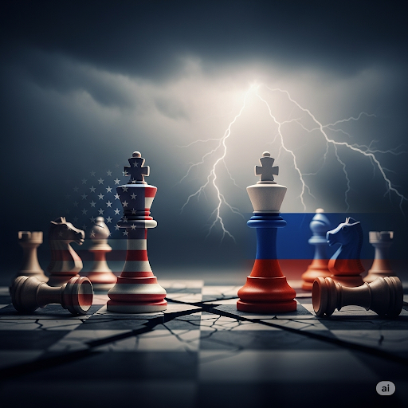

Historical Context: From Cold War to Hot Peace

The rivalry between the U.S. and Russia is deeply rooted in history. The Cold War (1947-1991) was marked by proxy conflicts, espionage, and an arms race that brought the world to the brink of nuclear annihilation. The fall of the Soviet Union in 1991 briefly promised a new era of cooperation, but NATO’s eastward expansion, U.S. interventions in the Middle East, and Russia’s resurgence under Vladimir Putin reignited tensions.

Today, the war in Ukraine has become the flashpoint. The U.S. and its NATO allies have poured billions into military aid for Kyiv, while Russia has doubled down, framing the conflict as an existential struggle against Western hegemony. With neither side willing to back down, the risk of a wider war grows by the day.

Escalation Pathways: Where Could Things Go Wrong?

1. Ukraine: The Immediate Tinderbox

- A Ukrainian strike deep inside Russian territory (or vice versa) could trigger a massive retaliation.

- NATO members supplying weapons could be drawn into direct conflict if Russia chooses to target supply lines in Poland or Romania.

2. Nuclear Posturing and Miscommunication

- Both nations possess thousands of nuclear warheads. A misread signal, a cyberattack on early-warning systems, or an accidental encounter could spiral into catastrophe.

- Putin’s repeated nuclear threats, though possibly bluffs, heighten the risk of miscalculation.

3. Proxy Wars Spinning Out of Control

- Syria, Africa, and the Arctic are emerging battlegrounds where U.S. and Russian interests clash. A localized skirmish could quickly escalate.

4. Economic Warfare and Desperation

- Sanctions have crippled Russia’s economy, but desperation could push Moscow toward more aggressive actions.

- Energy disruptions (e.g., sabotage of pipelines) could provoke retaliatory strikes.

The Role of NATO and China

NATO’s unity is both a deterrent and a potential accelerant. Article 5 commitments mean an attack on one member could drag the entire alliance into war. Meanwhile, China watches closely; a U.S.-Russia conflict could either pull Beijing into the fray or give it an opportunity to assert dominance in Asia.

Diplomacy on Life Support

Dialogue between Washington and Moscow is virtually nonexistent. Trust has eroded, and leaders on both sides frame the conflict in zero-sum terms. Without backchannel negotiations or a ceasefire in Ukraine, the path to de-escalation narrows.

Conclusion: A Call for Restraint

The world cannot afford a U.S.-Russia war. The human cost would be unimaginable, and the economic fallout would plunge the globe into chaos. Leaders must prioritize diplomacy over brinkmanship, revive arms control talks, and seek off-ramps in Ukraine before it’s too late.

History shows that wars often start by accident—through misjudgment, pride, or sheer folly. The question is: Will wisdom prevail this time, or will we sleepwalk into disaster?

Munir Dar

Publisher & Chief Editor, Layalpur Post, Canada

(This column reflects the author’s views and not necessarily those of Layalpur Post.)